# Assignment4: Final word on composition | Must for all

|  |  |
| --- | --- |
| **Car database: Hierarchal model** | 1 |

**Dear students, now that we have had more than a couple of sessions discussing the class hierarchies and composition models, I guess it is about time to move ahead and conduct a general mass assignment to help you understand the concepts more crisply.**

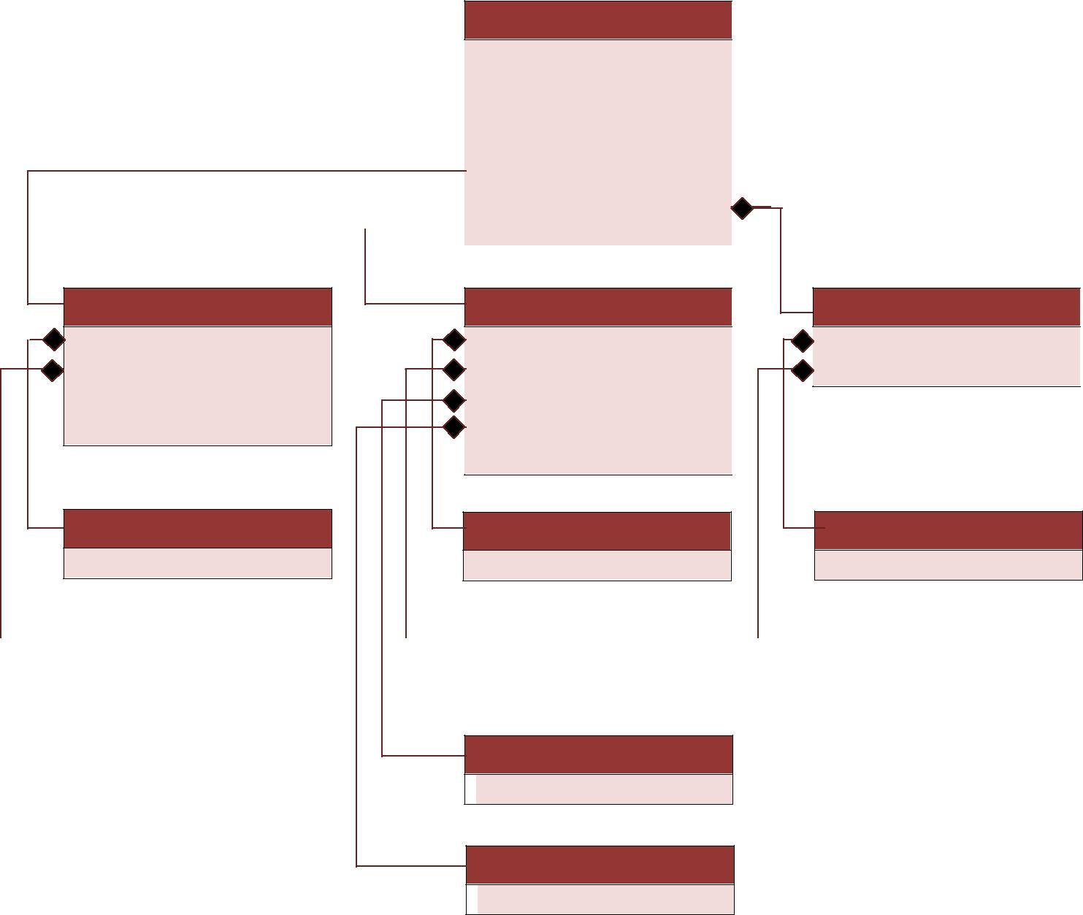

**Car**

ModelNumber:String Brand:String Type:String Seats:Integer Eng:Engine Cha:Chasis Whe:Wheel

**Company**

Type:String

**Rims**

Type:String

|  |  |  |
| --- | --- | --- |
| **Engine** | **Wheel** | **Chassis** |
| Cyl:Cylinder | T:Type | Com:Company |
| Hp:HorsePower | Cou:Colour | Num:ChasisNumber |
| NoOfGears:Integer | Com:Company |  |
| TopSpeed:Integer | R:Rims |  |
|  | Size:Integer |  |
| **Cylinder** | **Type** | **Company** |
| Cy:int | Type:String | C:String |

|  |  |  |  |  |  |  |  |  |  |
| --- | --- | --- | --- | --- | --- | --- | --- | --- | --- |
|  | **HorsePower** |  | | | | |  |  | **ChasisNumber** |
|  |  | **Colour** | |  |
|  |  |  |  |
| Hp:int |  | Type:String | CN:Integer | |

**Figure 1.1: Hierarchy model for a car**

**information storage database.**

# Assignment4: Final word on composition | Must for all

|  |  |
| --- | --- |
| **Following your progress, I am assigning you the above mentioned class hierarchy** | 2 |
| **model, first of all you have to identify the relationship amongst all the following** |
| **classes and later on express them in C++ code. While designing the following class** |

model in C++, you must not forget to make use of all the following C++ concepts:

* **Private data members**
* **Public member methods**
  + **Getters/Setters**
  + **Default parameterized Constructors**
  + **Copy constructors**
  + **Destructors**
* **Dynamic memory allocation/ deallocation**
* **Composition (if required you must also use Aggregation/ Association)**
* **Member initializing lists**
* **\*Bonus point: Operator overloading (Only: “<<” & “>>” operators)+**

In your assignment, you must write a proper driver program, which inputs all the details regarding a user’s car.

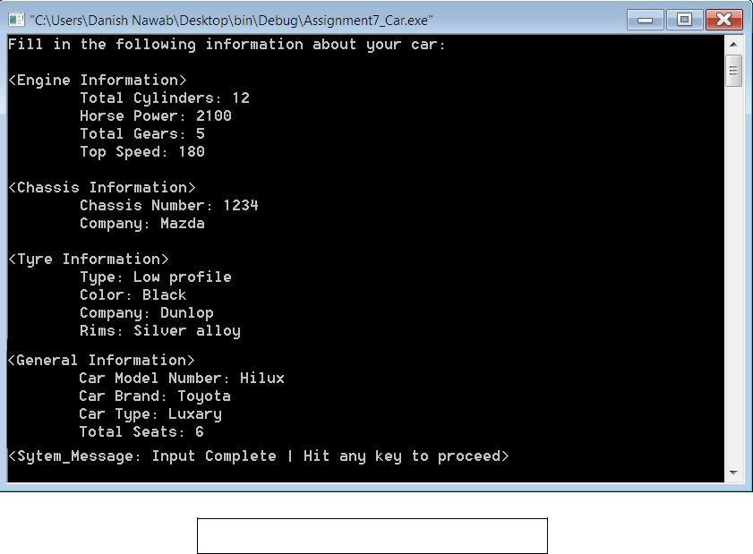

**Figure 1.2: Input stream - Car database**

# Assignment7: Final word on composition | Must for all

|  |  |
| --- | --- |
| **Once the user is done with the input, your program shall then display all the details** | 3 |
| **entered by the user, in the following sequence:** |

**Figure 1.3: Output stream - Car database**

All will be same as mentioned above, except from the fact that your program must not input only one car details, instead just when the program begins execution, it shall prompt for the number of records user want to enter. If user enters “3”, it shall prompt for all above mentioned fields for 3 different cars.

At the end, your program shall display all “3” records.

[Hint: User can enter any integer at the beginning, hence using fixed size arrays is not a good solution. Make use of dynamic array of objects instead]